Step by Step: Creating and Responding to Meetings (Outlook) Level 1



**On Outlook Web App(OWA)**

1. The very first thing you want to do is open up your browser.
2. On the URL type <https://login.microsoftonline.com>

A window should pop up like this:

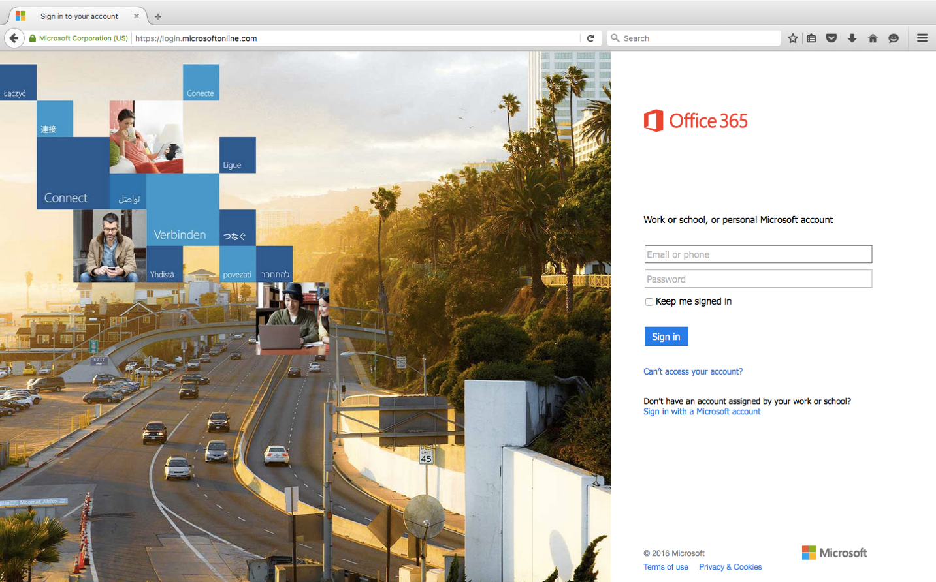

1. Here, you will enter your username and password.
2. Once you are signed in, a window should change into this: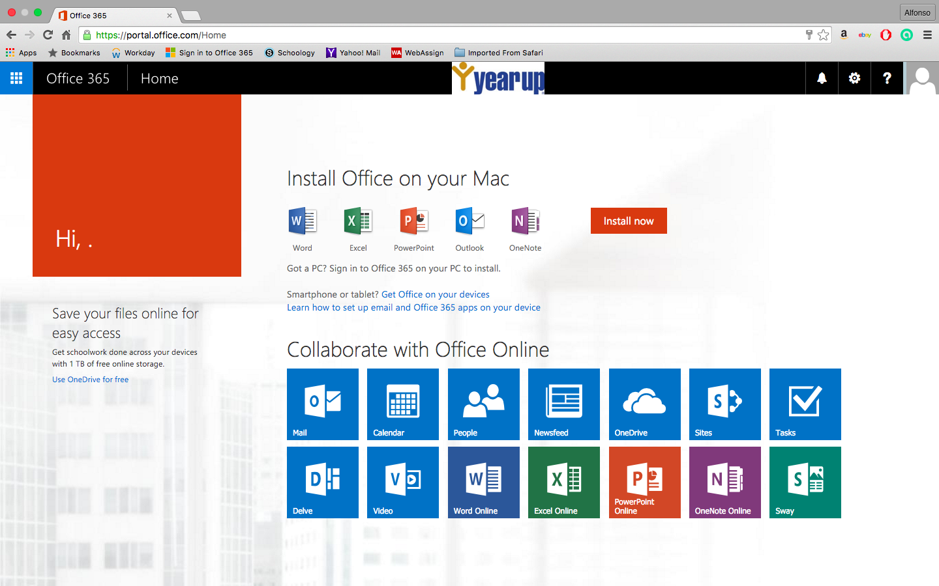
3. The next step, is to click the calendar icon. A window will pop up: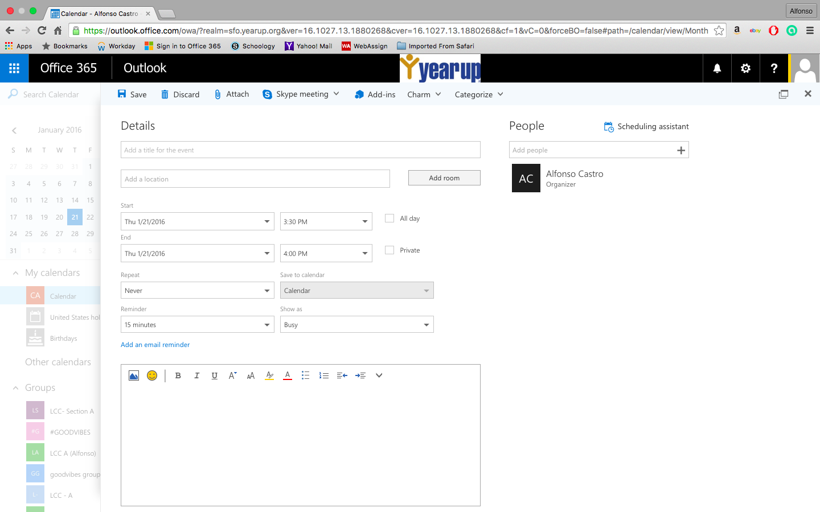
4. As you can see, your meeting can be as detailed as you want. You can add a title, location, start and end time, reminder, and there is a text box for additional information you might want to add.
5. On the top right, you have the ability to add recipients of the meeting request by clicking on the “+” button.
6. Once you are ready, you send the meeting invite and the receiver will see this window:

(Here you can choose to “Accept”, “Tentative”, “Decline”, or “Propose new time” to the original sender.)

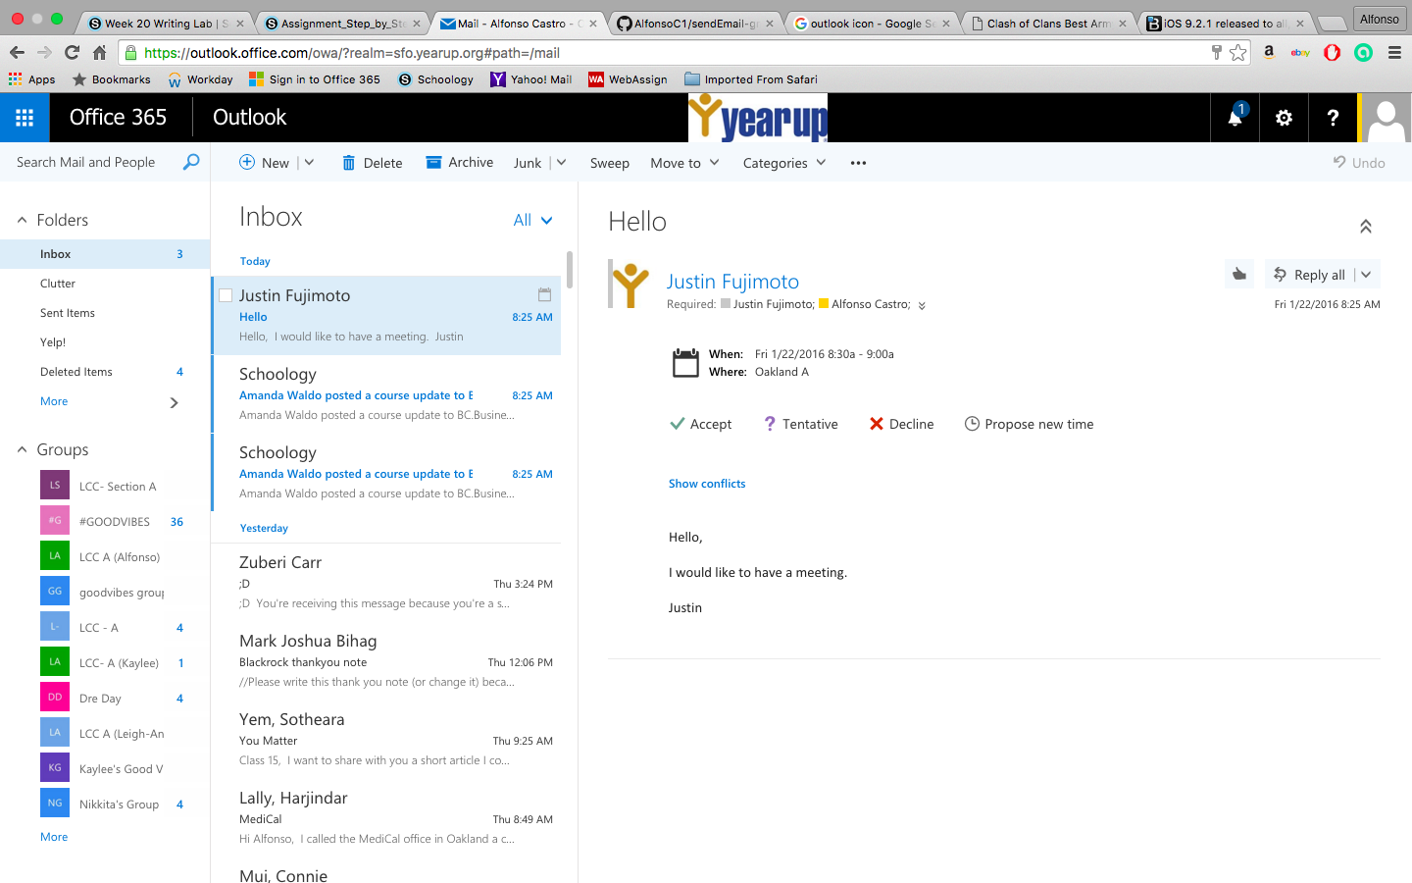

1. You have successfully created, accepted or decline a meeting request!

**On Outlook via installed software (Desktop App)**

1. The first thing you want to do is open the Outlook Desktop App. As you can see, I opened the desktop app that is located in the bottom right.
2. Once you open it this window will pop up (if you are signed-in, if not, log in):

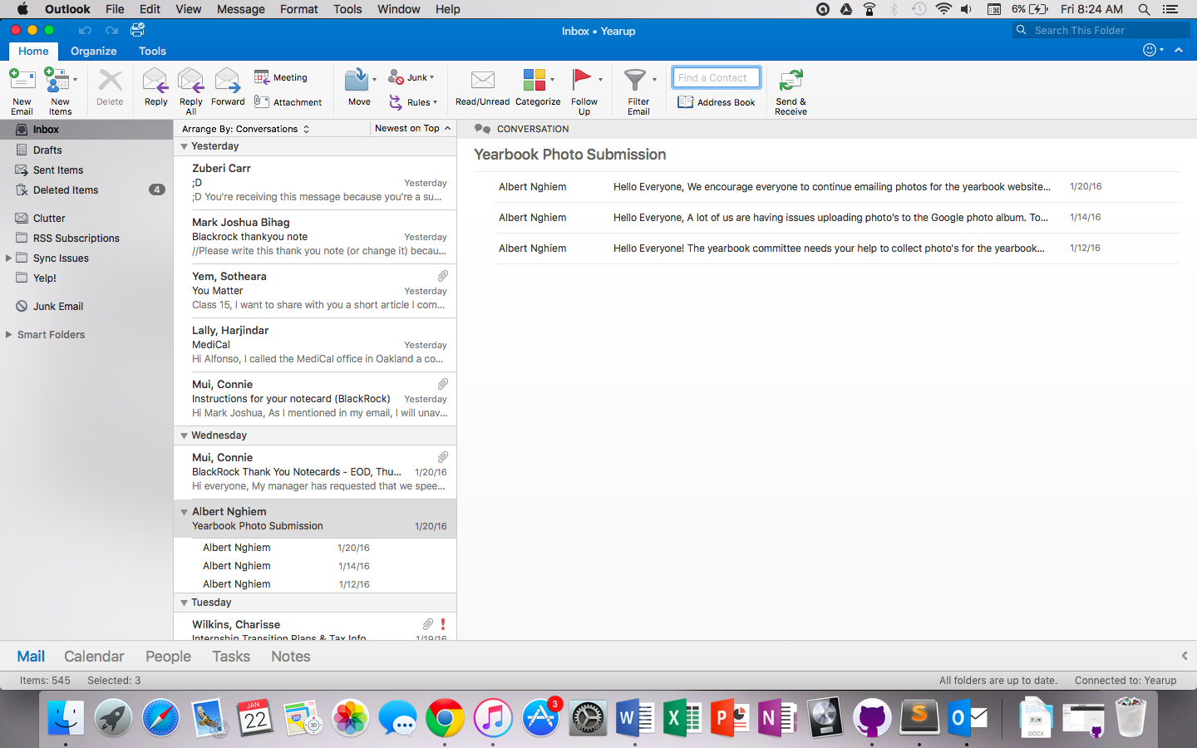

1. To create a meeting request, you will have to click on new items on the top left:

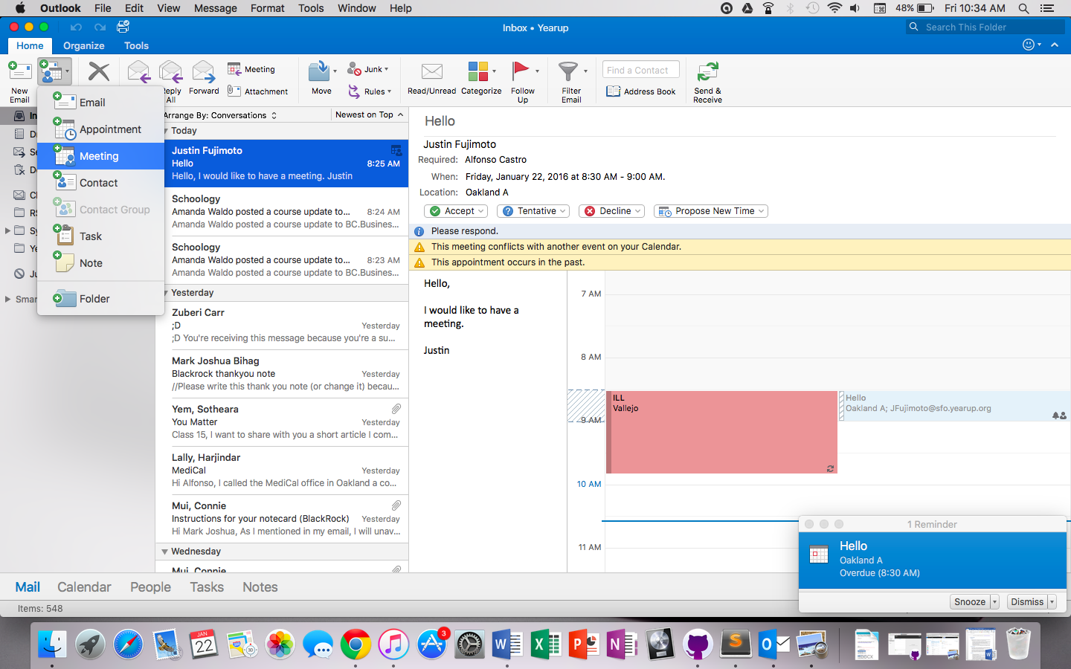

1. This window should pop up: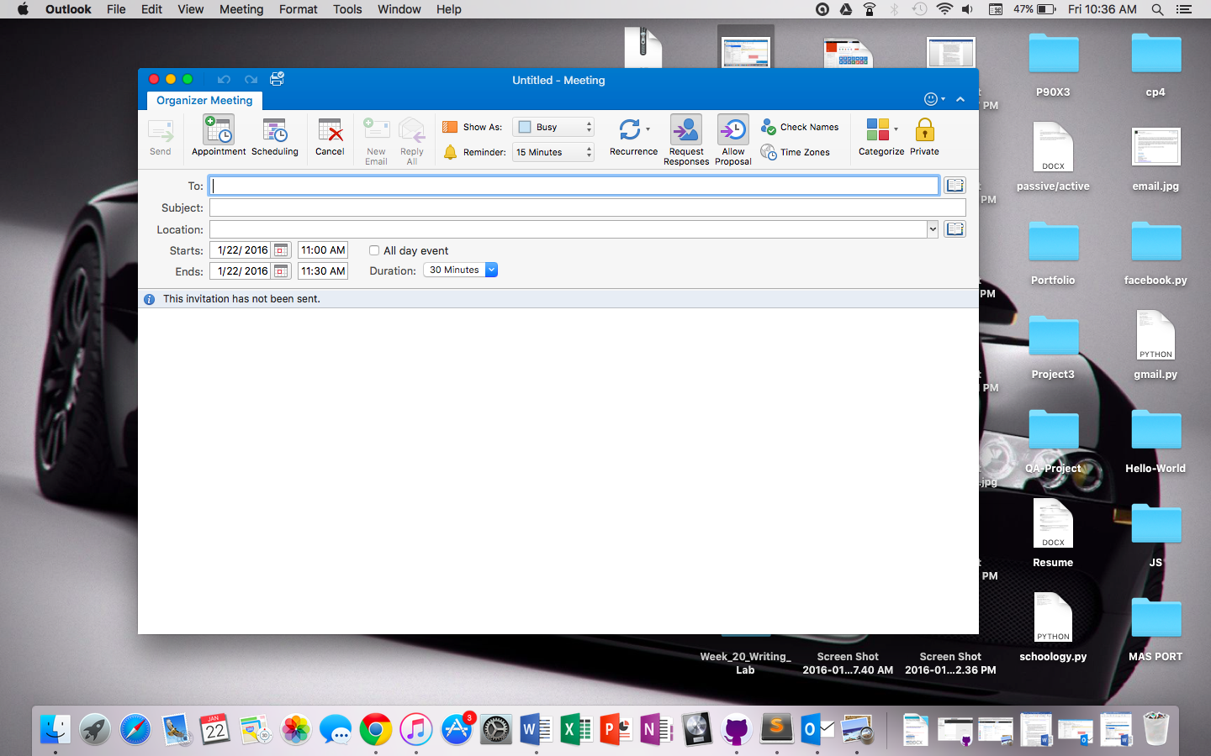
2. Here you can add details about the meeting. You can set the title, subject, location, etc. Once you are done, click send.
3. When receiving a meeting request, it will look something like this: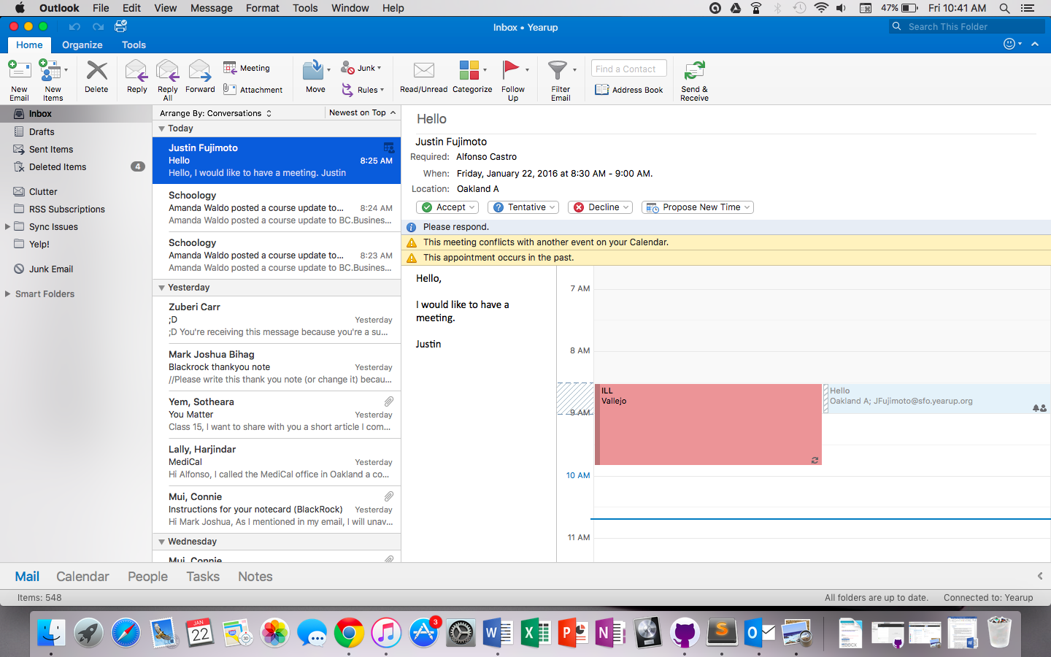
4. Kind of similar to the Web App, you can click “Accept”, “Tentative”, “Decline”, or “Propose New Time”.
5. You have successfully created, accepted or decline a meeting request!